This is mostly part 1 with some part 2 thrown in.  I can convert this into a nice looking document if you want.  I want to hear thoughts about this proposed project setup before I progress too far into this.

Ideas:

For task 1, I have already began working on a way to read in a folder with all the files.  Perhaps this is a better starting point than the script file with just file locations?  This allows you to just throw all your data in .csv or .txt format into a folder and then the script will automatically pull the data from each file.  Can even make it so you don't need to specify a folder directory in the future.  I think this is the first step towards automation.

Next step would be to use some open source tools to turn our scripts into a single executable file that can be downloaded and ran by anyone. Plenty of ways to do this including [http://www.py2exe.org/](https://bn1prd0113.outlook.com/owa/redir.aspx?C=_qXriWTT0kWY2thMpft4Q-EFKrjQZdAILzH2RQ7unrKQNJrfTKtofB2HA8A-UBpV39znbKYeos8.&URL=http%3A%2F%2Fwww.py2exe.org%2F), [http://www.pyinstaller.org/](https://bn1prd0113.outlook.com/owa/redir.aspx?C=_qXriWTT0kWY2thMpft4Q-EFKrjQZdAILzH2RQ7unrKQNJrfTKtofB2HA8A-UBpV39znbKYeos8.&URL=http%3A%2F%2Fwww.pyinstaller.org%2F), and much more.  Therefore to run the simulation up to this point, the user compiles all the data into a folder, sticks that folder in the same directory as the exe, runs the exe, gets a file (or folder) of the results.

A GUI can be introduced down the road to make the interactions required by the user a little bit easier. Shows graphs of data? Allows user to change certain values?  That way, users aren't having to use another program to graph the results.  There's the ability to graph in Python so it can be built right into the scripts unless there is a desire to use something external to provide more graphing flexibility.

All of the above would fall under automation.py so that it can be updated independently from simulation.py.  I'm attaching my idea of automation.py. It currently asks for a folder with .csv or .txt files (which I will attach --- make sure to unzip the folder first) and then asks for the folder you want the modified files to go.  This script is calling a simulation function I made which increments all values by 1.  It then returns the modified dictionary which then is converted into new .csv and .txt files.

Down at lines 91 in 92 in automation.py, you can see my idea about how Simulation as a function should work.  Here's a picture that shows these ideas (slightly a mess, and backwards but I think it shows some of my ideas).

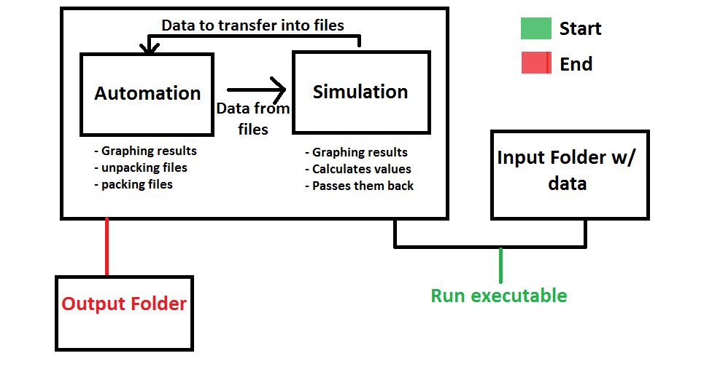

Nathan, how does this look? Is this the general idea you had in mind?

Resources:

[http://docs.python.org/2/library/stdtypes.html#mapping-types-dict](https://bn1prd0113.outlook.com/owa/redir.aspx?C=_qXriWTT0kWY2thMpft4Q-EFKrjQZdAILzH2RQ7unrKQNJrfTKtofB2HA8A-UBpV39znbKYeos8.&URL=http%3A%2F%2Fdocs.python.org%2F2%2Flibrary%2Fstdtypes.html%23mapping-types-dict) (Dictionaries in python)

[http://docs.scipy.org/doc/numpy/reference/generated/numpy.array.html](https://bn1prd0113.outlook.com/owa/redir.aspx?C=_qXriWTT0kWY2thMpft4Q-EFKrjQZdAILzH2RQ7unrKQNJrfTKtofB2HA8A-UBpV39znbKYeos8.&URL=http%3A%2F%2Fdocs.scipy.org%2Fdoc%2Fnumpy%2Freference%2Fgenerated%2Fnumpy.array.html) (Numpy arrays)

[http://docs.python.org/2/library/os.html](https://bn1prd0113.outlook.com/owa/redir.aspx?C=_qXriWTT0kWY2thMpft4Q-EFKrjQZdAILzH2RQ7unrKQNJrfTKtofB2HA8A-UBpV39znbKYeos8.&URL=http%3A%2F%2Fdocs.python.org%2F2%2Flibrary%2Fos.html) (os module used to create folders and change directories)